1. What are the advantages of Bootstrap ?

* It's responsive.
* It automatically resizes images and elements.
* It's grid-based.
* It includes major components.
* It's built on JavaScript and CSS.
* It can easily be customized.
* It has a thriving community.
* It has many templates.

1. What is a Bootstrap Container, and how does it work?

* In Bootstrap, container is used to set the content's margins dealing with the responsive behaviors of your layout.

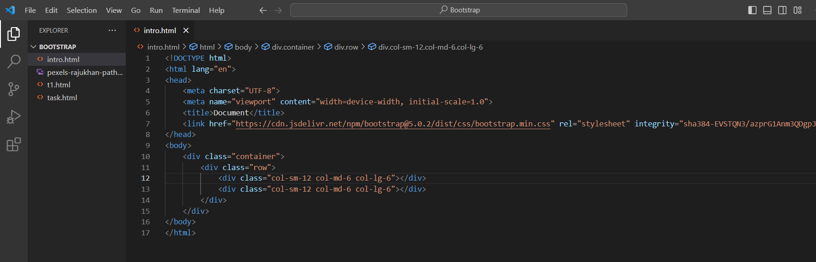

1. What are the default Bootstrap text settings?

* Bootstrap 4 uses a default font-size of 16px, and its line-height is 1.5. The default font-family is "Helvetica Neue", Helvetica, Arial, sans-serif. In addition, all <p> elements have margin-top: 0 and margin-bottom: 1rem (16px by default).

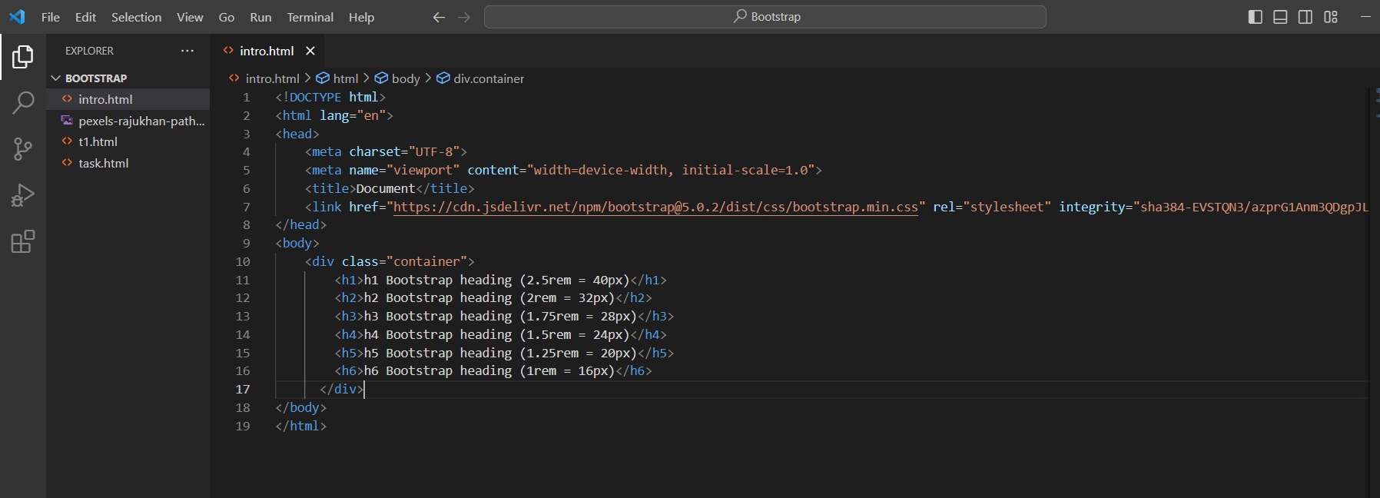

1. What do you know about the Bootstrap Grid System?

* Bootstrap's grid system uses a series of containers, rows, and columns to layout and align content. It's built with flexbox and is fully responsive.



1. What is the difference between Bootstrap 4 and Bootstrap 5

* The form elements in Bootstrap 4 have defaulted to the browser-provided view. However, in Bootstrap 5, the form elements have a custom design that enables them to have a consistent look and feel in all browsers. The new form controls are based on completely semantic, standard form controls

1. What is a Button Group, and what is the class for a basic Button Group?

* “Button Groups” in Bootstrap is a class of name “btn-group” which is used to create a series of buttons in groups (without spaces) vertically or horizontally.

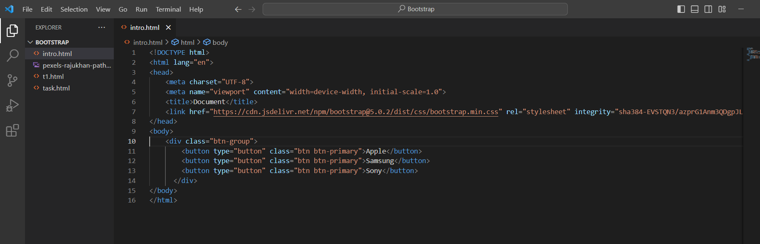

1. How can you use Bootstrap to make thumbnails?

* Add an <a> tag with the class of . thumbnail around an image.
* This adds four pixels of padding and a gray border.
* On hover, an animated glow outlines the image.

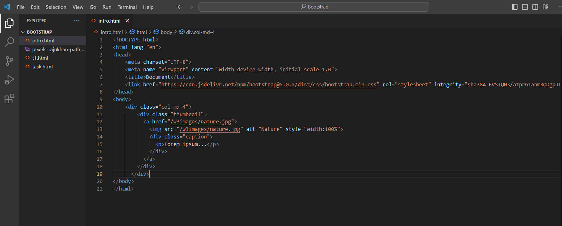

1. In Bootstrap 4, what is flexbox?

* Flexbox. The biggest difference between Bootstrap 3 and Bootstrap 4 is that Bootstrap 4 now uses flexbox, instead of floats, to handle the layout.

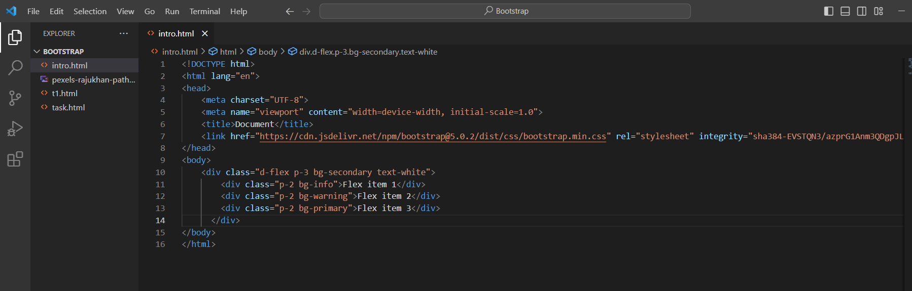

1. How can one create an alert in Bootstrap?

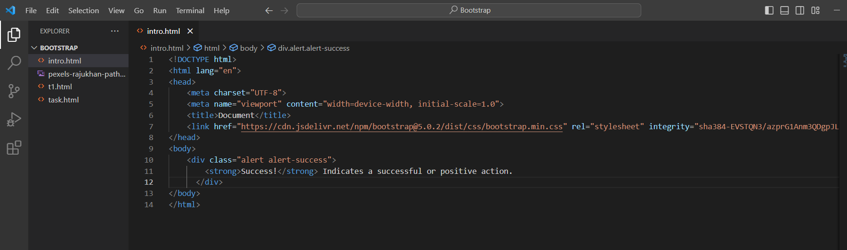

1. What is a bootstrap card and how would you create one?

* A card is a flexible and extensible content container. It includes options for headers and footers, a wide variety of content, contextual background colors, and powerful display options. If you're familiar with Bootstrap 3, cards replace our old panels, wells, and thumbnails.

